**How To Use Data Science to Find the Best Chinese Cuisine in NYC**

**Introduction**

This project explores the option of best Chinese cuisine in New York city. New York City (NYC) has two major hubs for Chinese food. Chinatown, Manhattan, and Flushing in Queens. New York is a major metropolitan area with more than 8.4 million (census.gov, 2019) people living within city limits. It has a population density of 28,000 residents per square mile. I decided to use NYC in my project and focus on finding best Chinese food in NYC. Chinese immigration to United States were restricted due to Chinese Exclusion Act. After being revoked in 1943, the Chinese slowly started growing as community. Chinatown, Manhattan, today has grown from the original ten blocks to the present inclusion of the once Italian and Jewish Lower East Side. The large influx of Cantonese-speaking Chinese immigrants provoked the extension of the neighborhood. In the 1970s-80s, the influx of Guangdong and Hong Kong immigrants began to develop newer portions of Manhattan’s Chinatown, going north of Canal Street and then later the east of the Bowery. Until the 1980s, the eastern portion of Chinatown, which is considered part of the Lower East Side, was developing more slowly as being part of Chinatown. With almost 60,000 (mascaulay.cuny.ed, 2020)Manhattan inhabitants reporting Chinese ancestry, the need to find and enjoy Chinese cuisine is on the rise. This report explores which neighborhoods and boroughs of New York City have the most as well as the best Chinese restaurants. Additionally, I will attempt to answer the questions “Where should one open a Chinese Restaurant?” and “Where should one stay If he/she wants great Chinese food?”

### Data

To answer above questions, we need to accumulate data. The data on New York City neighborhoods, boroughs should include boundaries, latitude, longitude, restaurants, and restaurant ratings and tips. There are numbers of API/Websites that provide us with this data.

New York City data containing the neighborhoods and boroughs, latitudes, and longitudes will be obtained from the data source: <https://cocl.us/new_york_dataset>

New York City data containing neighborhood boundaries will be obtained from the data source: <https://data.cityofnewyork.us/City-Government/Borough-Boundaries/tqmj-j8zm>

All data related to locations and quality of Chinese restaurants will be acquired from Foursquare via Foursquare API. We will utilize the Foursquare API with NYC neighborhoods data to request detailed restaurants data. For this we will use Request library in Python.

### Methodology

• Data is collected from <https://cocl.us/new_york_dataset> and cleansed and processed into a dataframe.

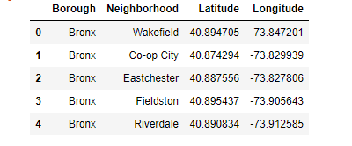

• I used python folium library to visualize geographic details of NYC and its boroughs and I created a map of NYC with boroughs superimposed on top. I used latitude and longitude values to get the visual as below:

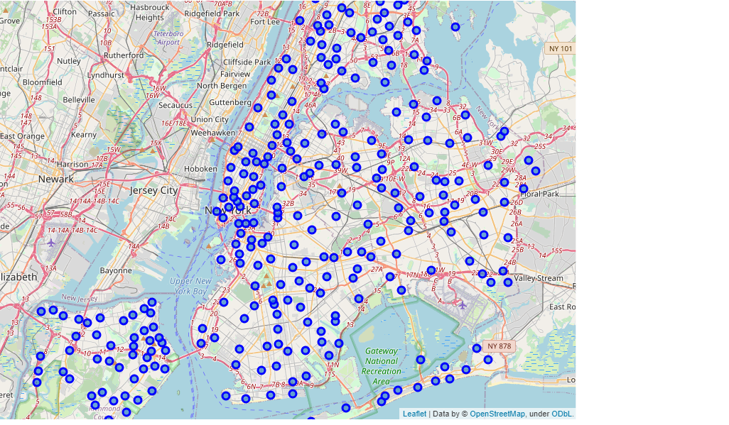

• Foursquare is used to locate all venues and then filter only for Chinese restaurants. Ratings, tips, and likes by users is counted and added to the dataframe.

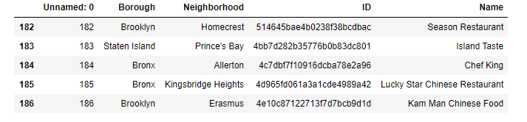

• We sorted data and calculate average rating

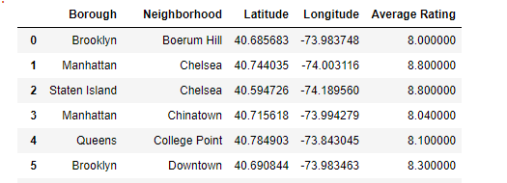

• Finally, the data be will be visually assessed using bar graph and maps from various Python libraries such as matplotlib and folium. These are used in result section.

### Problem Statement

1. What is the best location for Chinese cuisine in New York City?
2. In what Neighborhood and/or borough should I open a Chinese restaurant to have the best chance of success?
3. Where would I go in New York City to have the best Chinese food?

### Analysis

Click here for full code.

### Results

### Manhattan has the least number of neighborhoods per borough.

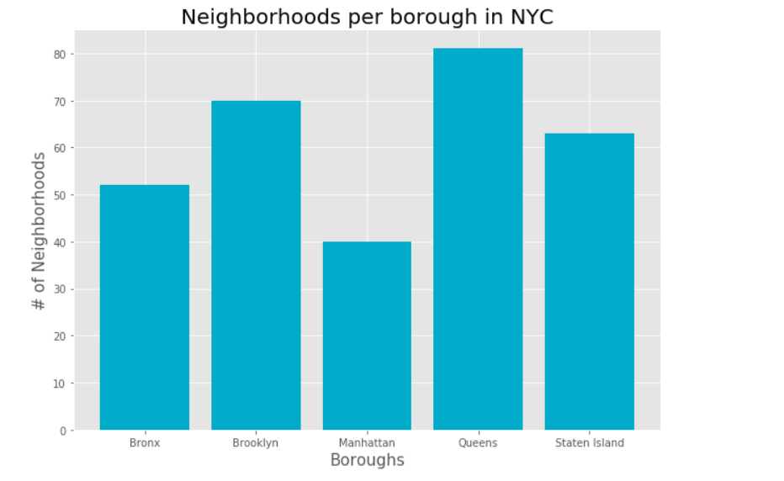

1. **Queens takes the lead in the most numbers of restaurants in NYC.**

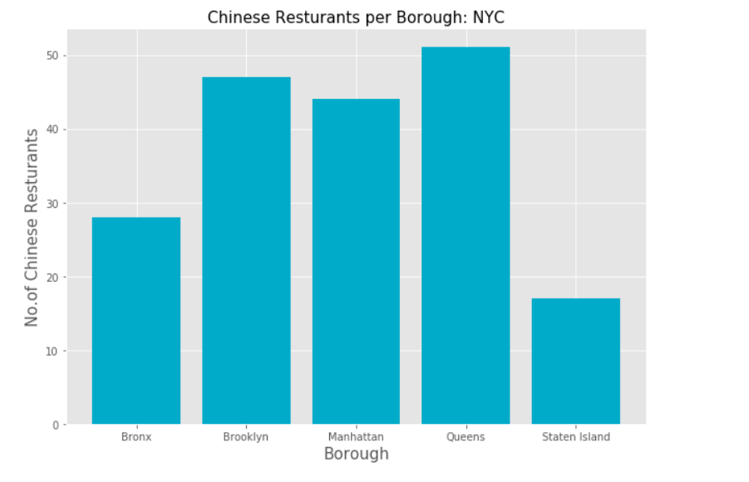

1. **The top six neighborhoods represent Queens, Manhattan, and Brooklyn boroughs. Chinatown in Manhattan holds the most Chinese Restaurants, 10.**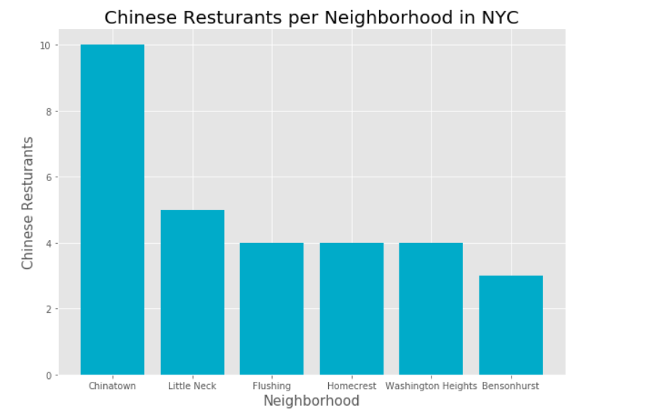
2. **Despite having the least number of Neighborhood, Manhattan has the highest rate restaurant with average rating of greater than 8.**

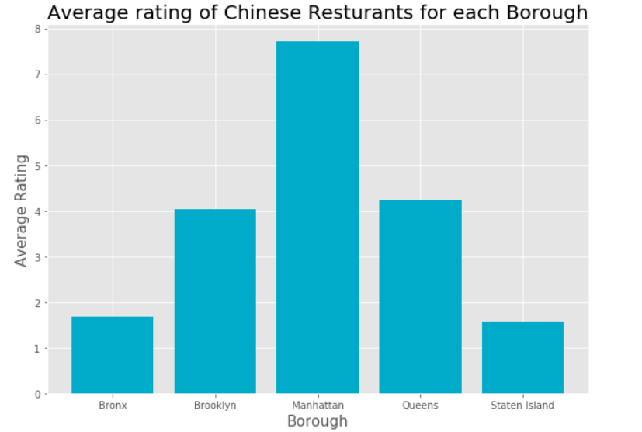

1. **Manhattan clearly has the highest rated Chinese restaurants out of all the boroughs. It certainly makes the competition tough and gives consumer lots of options to choose from.**

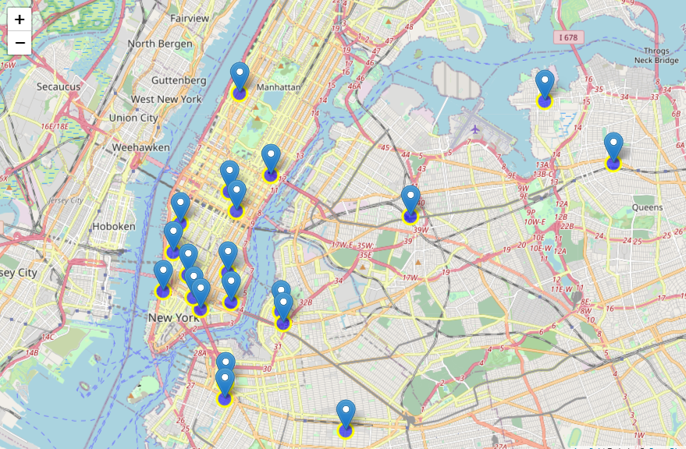

1. **Boroughs like Bronx and Staten Island provide less competition as they have a smaller number of Chinese restaurants as compared to other boroughs.** 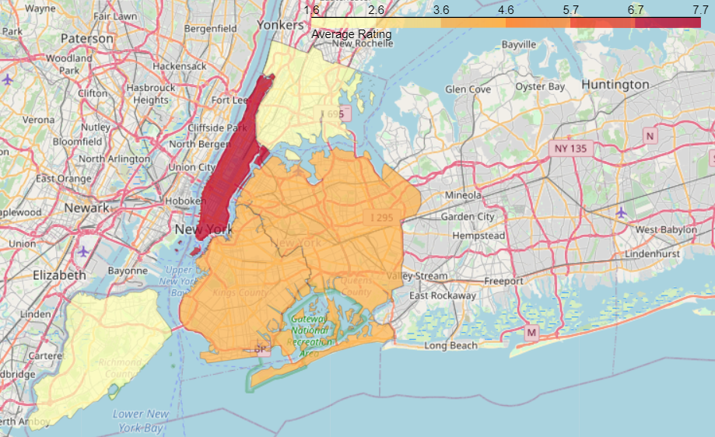
2. **Top five Chinese restaurants in NYC**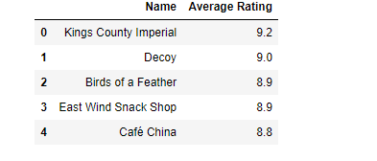
3. **Per NY Eatery Chinese restaurants open during pandemic.**

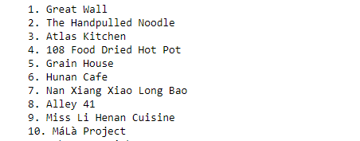

### Conclusion

Manhattan and Queens have the best rated Chinese restaurants on average. Queens slightly edges Brooklyn in rating. Staten Island and The Bronx have the least number of Chinese restaurants per borough. It is no surprise that Chinatown has the height number of Chinese restaurants in NYC. While surprisingly Little Neck in Queens takes the lead in the highest number of Chinese cuisines. Obvious choice would be Flushing in Queens. Despite Manhattan having the least number of neighborhoods in all five boroughs, and third on the list for most Chinese restaurants it has the highest rated Chinese restaurants. Based on this information, I would state that Manhattan is the best location for Chinese cuisine in NYC. If you would like to open a Chinese cuisine, then best shot of making it will be in Manhattan. Manhattan has most neighborhoods with average ratings exceeding 8.0 of a scale of 1.0 to 10.0 and it is still behind Brooklyn and Queens in number of Chinese restaurants making competition easier than in other two boroughs. Finally, I would go to Chelsea in Manhattan for the best Chinese food based on 1488 likes, Buddakan. As a final note, all the above analysis is depended on the accuracy of Foursquare data. A more comprehensive analysis and future work would need to incorporate data from other external databases.

# **References**

**Census.gov (06/09/2020) NYC Population**

<https://www.census.gov/quickfacts/newyorkcitynewyork>

**Mascaulay.cuny.edu (2020/06/09) Manhattan Chinese population**

<https://eportfolios.macaulay.cuny.edu/beemanneighborhoods/timelinehistory/>

[**Foursquare API**](https://developer.foursquare.com/)

**NY Eatery (open restaurants during pandemic)**

<https://ny.eater.com/maps/nyc-chinese-restaurant-delivery-takeout>